Pro Challenge Race Cars
RAFFLE TICKET

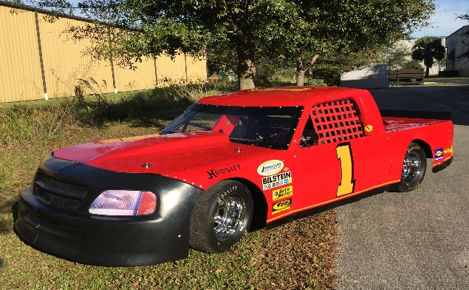

Please fill out the information below and submit to Pro Challenge Race Cars, 9110 16th Place, Vero Beach Florida 32966 with your form of payment. We will accept cash, check or credit card. If a credit card is used please note that there will be an additional $5 non-refundable fee ($105.00).
Name: ______________________________________
Address: ______________________________________
______________________________________
Telephone: ________________
Form of Payment:
____ Check _____ Cash _____ Credit Card
Credit Card # __________________________
Exp. Date: ________________
Security Code: ________________
Street # Card Pertains to: ________ Zip Code Card Pertains to: _________
Note: Drawing will be held on March 31st at Bronson Motor Speedway. 100 Tickets will be available for sale. If not enough tickets are sold, all monies will be refunded excluding the $5 credit card processing fee. If a credit card is used – you may fax this form with the pertinent information to (772)617-2204. Any questions, please call Pro Challenge Race Cars at (772)617-2203.

